**DAILY ONLINE ACTIVITIES SUMMARY**

|  |  |  |  |  |  |  |  |  |
| --- | --- | --- | --- | --- | --- | --- | --- | --- |
| **Date:** | **05-06-2020** | | | | | **Name:** | **Rohan Mahaveer** | |
| **Sem & Sec** | **6th B** | | | | | **USN:** | **4AL17CS077** | |
| **Online Test Summary** | | | | | | | | |
| **Subject** | | **OR** | | | | | | |
| **Max. Marks** | | **30** | | **Score** | | | **30** | |
| **Certification Course Summary** | | | | | | | | |
| **Course** | **Python Programming** | | | | | | | |
| **Certificate Provider** | | | **EBOX** | | **Duration** | | | **2 hrs** |
| **Coding Challenges** | | | | | | | | |
| Problem Statement: 1. Python program for slicing list and print 1st and last element  2. Java program to check if given linked list has a loop or not. | | | | | | | | |
| **Status:** YES, Completed all Programs | | | | | | | | |
| **Uploaded the report in Github** | | | | | **YES** | | | |
| **If yes Repository name** | | | | | <https://github.com/rohanmahaveer/daily-status> | | | |
| **Uploaded the report in slack** | | | | | **YES** | | | |

Online Test Details:

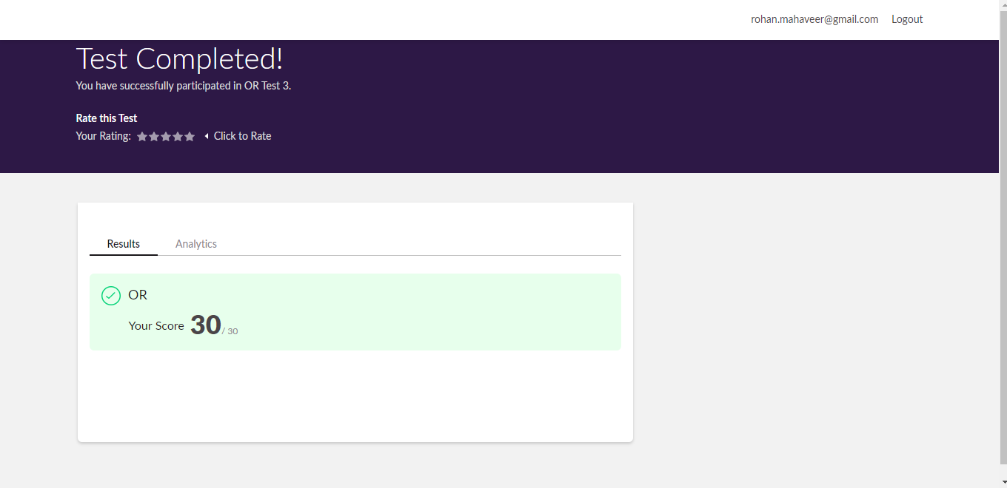

Scored 30 out of 30 in OR Test

Certification Course Details:

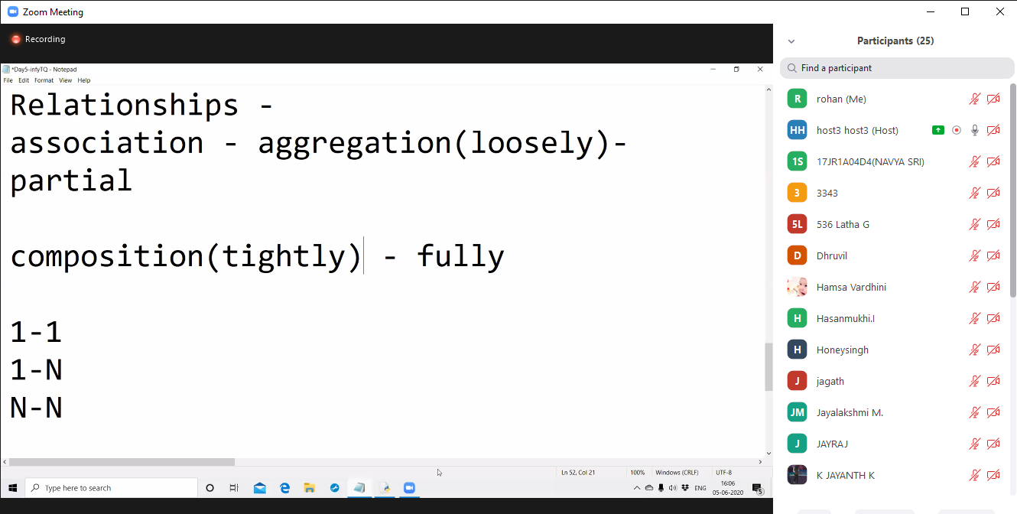

Today in certification I have attended online Python session in EBOX as mentioned above. I learnt about relationship between classes. Like one to one, many to many etc.

Coding Challenges Details:

Program1:

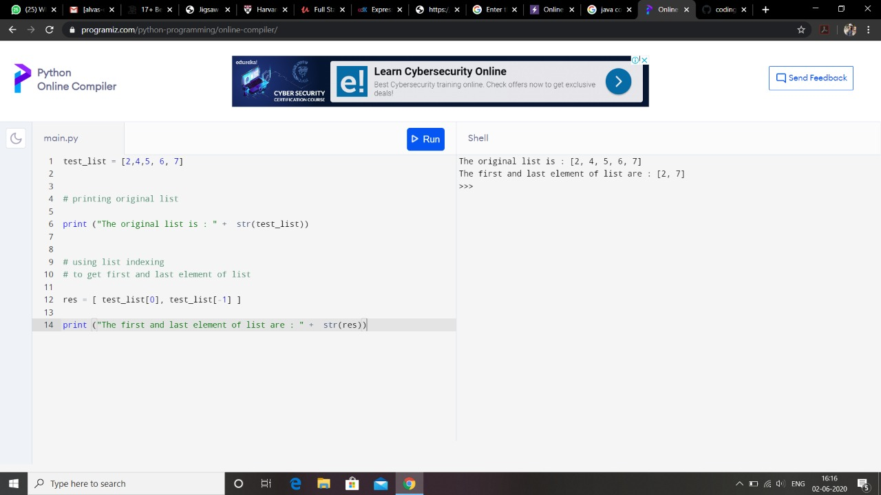

Program2:

